**McledSoft Cloud Server Data Analysis**

## Developed by:

Visual WWW, Inc.

## Problem Statement

Provide log Data Analysis for McledSoft cloud server. Find and analyze the server Error and Warning messages.

## Used Programming Language and Packages

The Data Analysis program was developed in Python using the following Open Source software:

1. Eclipse IDE (http://www.eclipse.org/)
2. PyDev plugin (http://www.pydev.org/)
3. Anaconda - is a completely free Python distribution including more than 400 of the most popular Python packages for science, math, engineering, and data analysis. (https://www.continuum.io/downloads).

* NumPy is the fundamental package for scientific computing with Python. It contains a powerful N-dimensional array object, sophisticated (broadcasting) functions, tools for integrating C/C++ and Fortran code and useful linear algebra, Fourier transform, and random number capabilities (http://www.numpy.org/).
* pandas is an open source library providing high-performance, easy-to-use data structures and data analysis tools for the Python programming language (http://pandas.pydata.org/)
* matplotlib is a python 2D plotting library which produces publication quality figures in a variety of hardcopy formats and interactive environments across platforms (http://matplotlib.org/)

## Output Log Server Data

The log server data was provide in Excel CSV file format (mcledsoft_networkactivities.csv) including the following columns: Time, Priority (Alert, Error, Info and Warning), Category, Message, Source, Destination, Notes and Rules.

## Data Analysis Program Design

The Python program was designed and developed using the standard MVC Design Pattern shown in Figure 1.

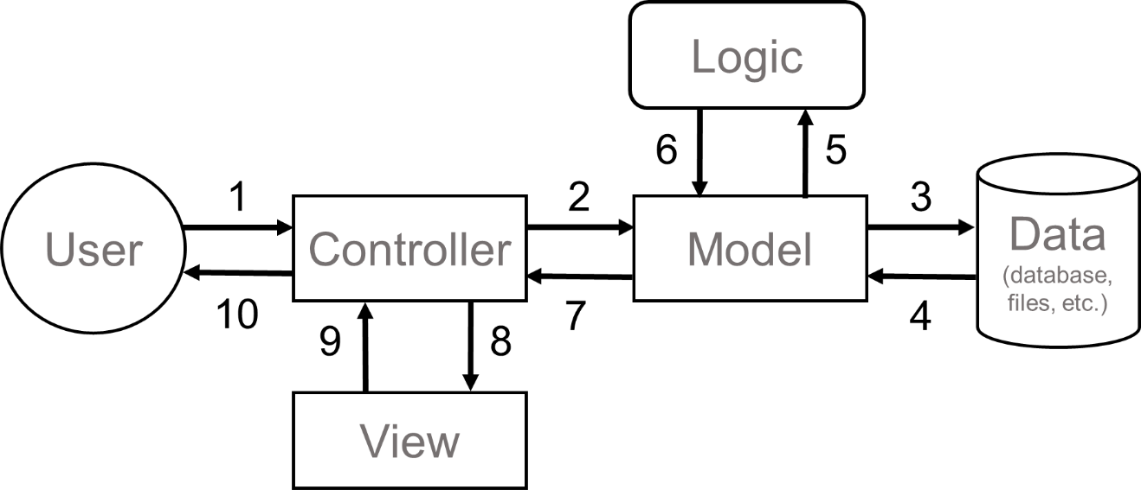

Figure 1. MVC Design Pattern (Model-View-Controller)

## Main() Function Code

The main.py module has the following code:

if __name__ == '__main__':

start_time = time.time()

main()

end_time = time.time()

elapse_time = end_time - start_time

print("Program Runtime: " + str(round(elapse_time, 3)) + " seconds" + "\n")

The main() funciton code is shown below:

from enum import Enum

from logserver.library.public import PublicLibrary

from logserver.controller.logservercontroller import LogServerController

# import sys

# import os

import time

class ColumnName(Enum):

Time = 0

Priority = 1

Category = 2

Message = 3

Source = 4

Destination = 5

Notes = 6

Rule = 7

def main():

"""

main() function

"""

# init the object class ----------------------------------------------------------------------------------------------------------------------------------------------------------

public_library = PublicLibrary()

logserver_controller = LogServerController()

# print specific column from the csv file

column_number = ColumnName.Priority.value

cvs_file_name = public_library.read_config_file_option('configuration\logserver.cfg', 'CSVFile', 'name')

csv_path_name = public_library.get_project_directory_path() + cvs_file_name

# print(csv_path_name)

# intel files path

file_path = "c:/users/ebonat/git/mcledsoft_server/"

# home file path

# file_path = "c:/users/ernest/git/mcledsoft_server.git/"

# -----------------------------------------------------------------------------------------------------------------------------------------------------------------------------------------

# Vertical Bar Chart: Log Server Message vs. Priority

csv_path_name = file_path + "mcledsoft_server/src/logserver/csv/mcledsoft_networkactivities.csv"

image_path_name = file_path + "mcledsoft_server/src/logserver/csv/frequency_distribution_priority_bar_vertical.png"

column_name = "Priority"

xlabel_name = "Priority"

ylabel_name = "Percent Frequency"

plot_title = "Log Server Message vs. Priority"

plot_legend = "Amount of Messages"

logserver_controller.frequency_priority_message_bar(csv_path_name, column_name, image_path_name, xlabel_name, ylabel_name, plot_title, plot_legend)

# --------------------------------------------------------------------------------------------------------------------------------------------------------------------------------------------

# Pie Chart: Log Server Message vs. Priority

csv_path_name = file_path + "mcledsoft_server/src/logserver/csv/mcledsoft_networkactivities.csv"

image_path_name = file_path + "mcledsoft_server/src/logserver/csv/frequency_distribution_priority_pie.png"

column_name = "Priority"

plot_title = "Log Server Message vs. Priority"

logserver_controller. frequency_priority_message_pie(csv_path_name, column_name, image_path_name, plot_title)

# --------------------------------------------------------------------------------------------------------------------------------------------------------------------------------------------

# Horizontal Bar Chart: Log Server Message vs. Error

csv_path_name = file_path + "mcledsoft_server/src/logserver/csv/mcledsoft_networkactivities.csv"

image_path_name = file_path + "mcledsoft_server/src/logserver/csv/frequency_distribution_error_bar_horizontal.png"

column_name = "Priority"

column_group = "Message"

column_for = "Error"

plot_color = "r"

plot_x_label = "Percent Frequency"

plot_y_label = "Error Message"

plot_title = "Log Server Message vs. Error"

plot_legend = "Amount of Messages"

logserver_controller.frequency_error_message_bar(csv_path_name, column_name, column_group, column_for, image_path_name, plot_x_label, plot_y_label, plot_color, plot_title, plot_legend)

# -------------------------------------------------------------------------------------------------------------------------------------------------------------------------------------------

# Horizontal Bar Chart: Log Server Message vs. Warning

csv_path_name = file_path + "mcledsoft_server/src/logserver/csv/mcledsoft_networkactivities.csv"

image_path_name = file_path + "mcledsoft_server/src/logserver/csv/frequency_distribution_warning_bar_horizontal.png"

column_name = "Priority"

column_group = "Message"

column_for = "Warning"

plot_color = "y"

plot_x_label = "Percent Frequency"

plot_y_label = "Warning Message"

plot_title = "Log Server Message vs. Warning"

plot_legend = "Amount of Messages"

logserver_controller.frequency_error_message_bar(csv_path_name, column_name, column_group, column_for, image_path_name, plot_x_label, plot_y_label, plot_color, plot_title, plot_legend)

# -------------------------------------------------------------------------------------------------------------------------------------------------------------------------------------------

## Priority Message Percent Frequency Distribution (Bar Chart)

The bar chart Percent Frequency Distribution for Log Sever Message vs. Priority is show below in Figure 1. As this figure shows there is 30.7% of occurred Errors (red light) and 26.8% of Warning (yellow light) messages.

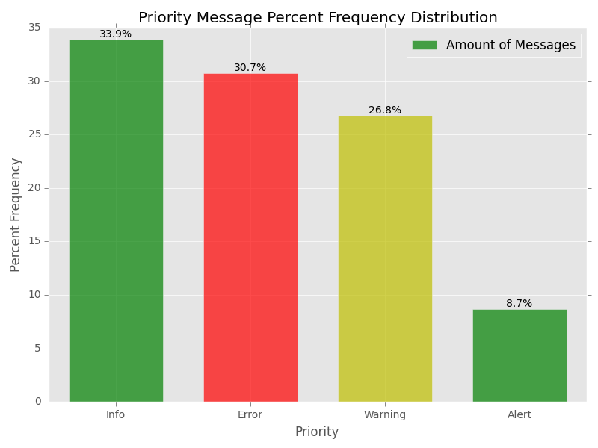

Figure 2. Priority Message Percent Frequency Distribution.

## Priority Message Percent Frequency Distribution (Pie Chart)

The Pie chart of the Priority Percent Frequency Distribution is show below in Figure 3.   
  
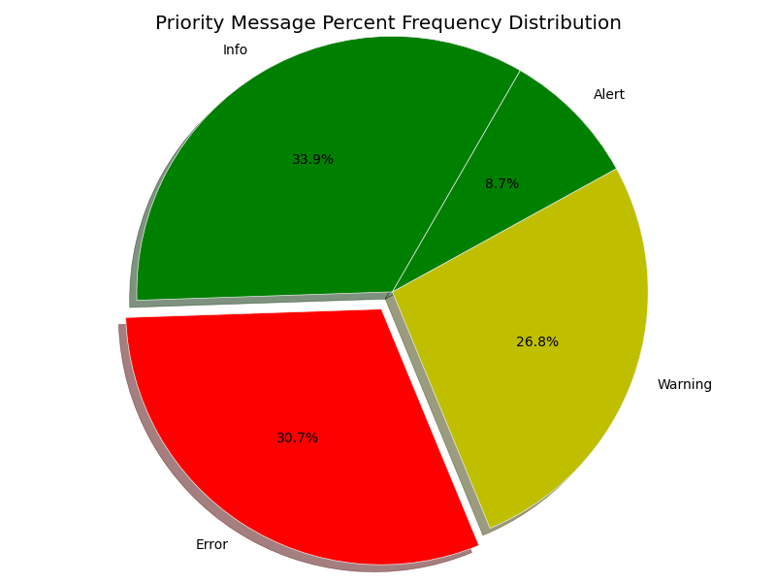

Figure 3. Priority Message Percent Frequency Distribution.

## Sever Error Percent Frequency Distribution (Horizontal Bar Chart)

The horizontal bar chart of the Sever Error Frequency Distribution is show in Figure 4. As the figure shows the most occurred Error messages are: Interface X0 Link Is Down (30%), Interface X8 Link Is Down (20%), Interface X5 Link Is Down (17%) and Interface X4 Link Is Down (15%). This info is good enough for the Server Administrator to start looking for the right solutions to fix these server occurred Errors.

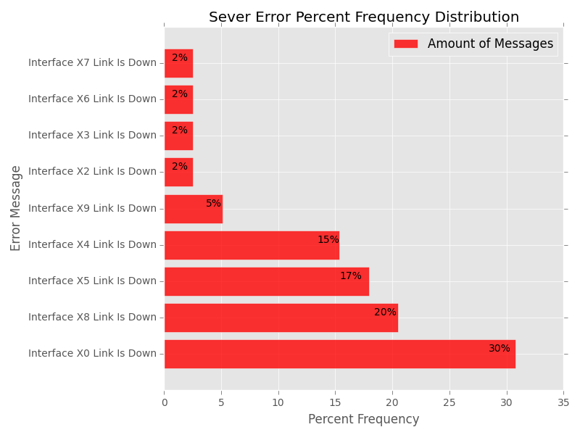

Figure 4. Sever Error Percent Frequency Distribution.

## Sever Warning Percent Frequency Distribution (Horizontal Bar Chart)

The horizontal Bar chart of the Sever Error Message Frequency Distribution is show in Figure 5. As the figure shows the most occurred Warning messages are: Interface X0 Link Is Down (32%), Interface X8 Link Is Down (20%), Interface X5 Link Is Down (20%) and Interface X4 Link Is Down (17%). The Interface X5 Link Is Down and Interface X8 Link Is Down.

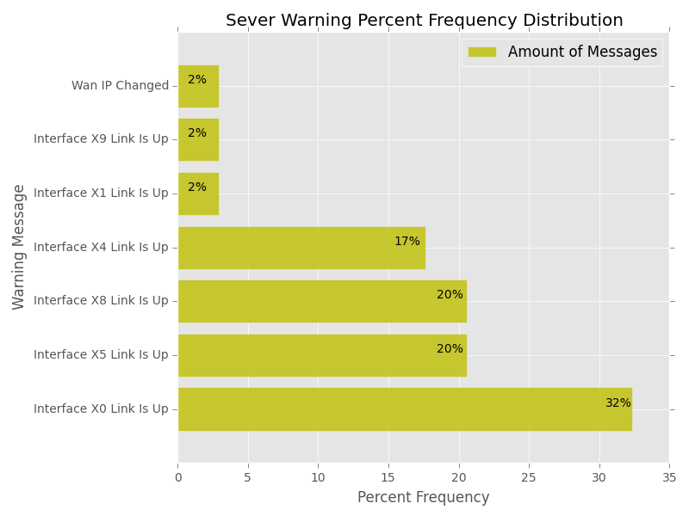

Figure 5. Sever Warning Percent Frequency Distribution.

## Conclusions

1. The sever Error and Warning messages are the second and third occurred (Fig.1) with 30.7% and 26.8% respectively.

2. The Error messages occurred in the following percent order:

* Interface X0 Link Is Down (30%)
* Interface X8 Link Is Down (20%)
* Interface X5 Link Is Down (17%)
* Interface X4 Link Is Down (15%)

3. The Warning messages occurred in the following percent order:

* Interface X0 Link Is Down (32%)
* Interface X8 Link Is Down (20%)
* Interface X5 Link Is Down (20%)
* Interface X4 Link Is Down (17%).

4. The Error messages have the same sequence as the Warning messages.

5. The serve messages Interface X0 Link Is Down (32%), Interface X8 Link Is Down (20%) and Interface X5 Link Is Down (20%) are most likely to occur at this point. It’s required by the System Admin

15 IT Resources General Application

1. Main Contact Info:

First and Last Name

Street

City

State

Zip Code

Phone

Fax

Email(s)

Website

Linkedin

Others

2. Emergency Contact:

Name: Phone: Email:

3. Technical References:

Name 1: Phone 1: Email 1:

Name 2: Phone 2: Email 2:

Name 3: Phone 3: Email 3:

4. Referrals:

Name 1: Phone 1: Email 1:

Name 2: Phone 2: Email 2:

Name 3: Phone 3: Email 3:

5. Signed: